**Hadoop Assignments**

**Problem Statement 01:**

**Solution:**

**Problem Statement 02:**

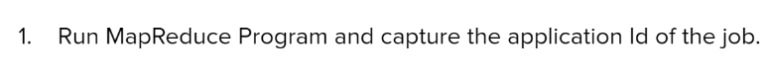



yarn application -list -appStates FINISHED

